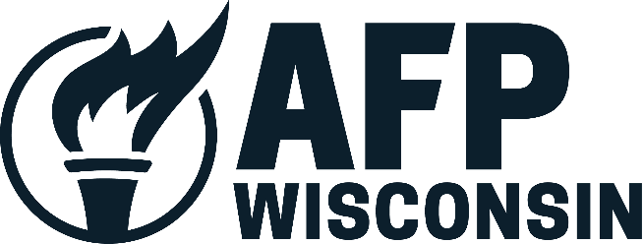

To: Members of the Senate Committee on Universities and Revenue

From: Megan Novak, State Director, Americans for Prosperity - Wisconsin
Date: April 25, 2023
Subject: Support for Senate Bill 1

Chairman Hutton, and members of the Senate Committee on Universities and Revenue, thank you for the opportunity to provide testimony today in favor of Senate Bill 1.

On behalf of thousands of Americans for Prosperity – Wisconsin activists across the state, we strongly support Senate Bill 1 to move Wisconsin to a flat income tax. We strongly believe that taxes should be simple, fair, and easy to understand. A flat tax achieves all of these goals, while also helping to jumpstart our economy and small businesses.

Wisconsin businesses are the backbone to our economy, and many small businesses in our state file under the personal income tax code as pass-through entities. Thousands of these main street businesses are paying a tax rate of 7.65%, an incredibly high tax burden that stifles economic growth and innovation. Our individual tax rates are uncompetitive at best, and hostile at worst. In fact, only nine states in this country have an income tax rate higher than our 7.65% top rate that so many small businesses pay right now.

Moving Wisconsin to a 3.25% flat tax will:
- Allow small businesses to invest in their employees, business expansion, and their communities
- Attract more families to our state with a much more competitive tax rate
- Keep more of our hard-earned money in our pockets, instead of sending it to Madison

The Legislature has the opportunity to transform Wisconsin for the better with Senate Bill 1 for generations to come. Wisconsin’s small businesses, families and economy will all be better off with the passage of this needed legislation. Thank you for your consideration and support of Senate Bill 1.

